GENERAL LOGIC QUESTIONS-HARDER LEVEL QUESTIONS

<__question>

Type=1

<__block>

Choose the number that is $\frac{1}{4}$ of $\frac{1}{2}$ of $\frac{1}{5}$ of 200 ?

<__block>

[A] 2

<__block>

[B] 5

<__block>

[C] 10

<__block>

[D] 25

<__block>

[B]

<__question>

Type=1

<__block>

Which larger shape would be made if the two sections are fitted together ?



<__block>

[A] 

<__block>

[B] 

<__block>

[C] 

<__block>

[D] 

<__block>

[C]

<__question>

Type=1

<__block>

Find the next number 3, 4, 8, 17, 33, ___?

<__block>

[A] 50

<__block>

[B] 54

<__block>

[C] 58

<__block>

[D] 62

<__block>

[C]

<__question>

Type=1

<__block>

My Successor’s father is my father’s son, and I don’t have any brothers or sons. Who is my successor ?

<__block>

[A] Father

<__block>

[B] Daughter

<__block>

[C] Niece

<__block>

[D] Nephew

<__block>

[B]

<__question>

Type=1

<__block>

Choose the word most similar to trustworthy ?

<__block>

[A] Reliable

<__block>

[B] Resolute

<__block>

[C] Insolent

<__block>

[D] Relevant

<__block>

[A]

<__question>

Type=1

<__block>

If you count from 7 to 100, how many 7’s are there?

<__block>

[A] 10

<__block>

[B] 11

<__block>

[C] 20

<__block>

[D] 21

<__block>

[B]

<__question>

Type=1

<__block>

Four years ago Jane was twice as old as Sam, four years from now Sam will be $\frac{3}{4}$ of Jane’s age. How old is Jane now ?

<__block>

[A] 8

<__block>

[B] 10

<__block>

[C] 12

<__block>

[D] 14

<__block>

[C]

<__question>

Type=1

<__block>

If you re-arrange the letters CIFAIPC you would have the name of a(n)?

<__block>

[A] Animal

<__block>

[B] Ocean

<__block>

[C] River

<__block>

[D] Country

<__block>

[B]

<__question>

Type=1

<__block>

The day before the day before yesterday is three days after Saturday. What day is it ?

<__block>

[A] Monday

<__block>

[B] Tuesday

<__block>

[C] Thursday

<__block>

[D] Friday

<__block>

[D]

<__question>

Type=1

<__block>

Please find the missing number 4, 5, 8, 17, 44, __?

<__block>

[A] 97

<__block>

[B] 38

<__block>

[C] 125

<__block>

[D] 103

<__block>

[C]

<__question>

Type=1

<__block>

If John needs 13 bottles of water from the store and can only carry 3 at a time. How many trips must John make to the store ?

<__block>

[A] 6

<__block>

[B] 5

<__block>

[C] 4

<__block>

[D] 3

<__block>

[B]

<__question>

Type=1

<__block>

If you re-arrange the letters TCEHAEH you would have the name for a(n) ?

<__block>

[A] Animal

<__block>

[B] Ocean

<__block>

[C] River

<__block>

[D] Country

<__block>

[A]

<__question>

Type=1

<__block>

Which one of the numbers does not belong in the following series 2 – 3 – 6 – 7 -8 - 14 – 15 - 30 ?

<__block>

[A] 3

<__block>

[B] 7

<__block>

[C] 8

<__block>

[D] 15

<__block>

[C]

<__question>

Type=1

<__block>

At a conference 12 members shook hands with each other before and after their meeting. How many handshakes occurred?

<__block>

[A] 132

<__block>

[B] 145

<__block>

[C] 144

<__block>

[D] 121

<__block>

[A]

<__question>

Type=1

<__block>

Which letter comes next S, M, H, D, W, M, ___ ?

<__block>

[A] L

<__block>

[B] V

<__block>

[C] Y

<__block>

[D] T

<__block>

[C]

<__question>

Type=1

<__block>

The day after tomorrow is four days before Monday. What day is it today ?

<__block>

[A] Thursday

<__block>

[B] Friday

<__block>

[C] Monday

<__block>

[D] Tuesday

<__block>

[C]

<__question>

Type=1

<__block>

6121135 is to flame as 21215120 is to ?

<__block>

[A] voice

<__block>

[B] bald

<__block>

[C] bloat

<__block>

[D] castle

<__block>

[C]

<__question>

Type=1

<__block>

Which best continues the following number series

1, 20, 39, 58, 77, 96 __ ?

<__block>

[A] 105

<__block>

[B] 104

<__block>

[C] 120

<__block>

[D] 115

<__block>

[D]

<__question>

Type=1

<__block>

If Bob sold 15 apples in a working week, what is the average number of apples he sells each day?

<__block>

[A] 10

<__block>

[B] 7

<__block>

[C] 3

<__block>

[D] 15

<__block>

[C]

<__question>

Type=1

<__block>

If it takes 2 hours to drive to City A and the city is 120 kms away, at what speed would the vehicle be driving at ?

<__block>

[A] 120

<__block>

[B] 100

<__block>

[C] 80

<__block>

[D] 60

<__block>

[D]

<__question>

Type=1

<__block>

The words “inclusive” and “exclusive have :?

<__block>

[A] the same meaning

<__block>

[B] different meanings

<__block>

[C] are the opposite in meaning

<__block>

[D] are 2 different languages

<__block>

[C]

<__question>

Type=1

<__block>

If you have a cube which is 5m x 5m, what is the cubic meters this container would hold ?

<__block>

[A] 125

<__block>

[B] 150

<__block>

[C] 175

<__block>

[D] 200

<__block>

[A]

<__question>

Type=1

<__block>

What does the acronym R.S.V.P. stand for ?

<__block>

[A] Realtor selling vacant plot

<__block>

[B] Respond, s’il vous plait

<__block>

[C] Roasted salmon and vegetable pilaf

<__block>

[D] Resolution – Spirit – Valour - Prowess

<__block>

[B]

<__question>

Type=1

<__block>

Which one of the numbers does not belong in the following series 3 – 5 - 7 – 11 – 14 – 17 ?

<__block>

[A] 3

<__block>

[B] 7

<__block>

[C] 14

<__block>

[D] 17

<__block>

[C]

<__question>

Type=1

<__block>

The word particular is the opposite meaning of ?

<__block>

[A] distinct

<__block>

[B] vague

<__block>

[C] exacting

<__block>

[D] fussy

<__block>

[B]

<__question>

Type=1

<__block>

Select the item below that would complete the pattern ?

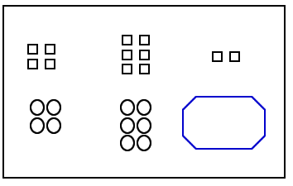

<__block>

[A] 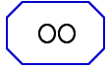

<__block>

[B] 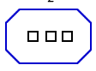

<__block>

[C] 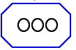

<__block>

[D] 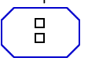

<__block>

[A]

<__question>

Type=1

<__block>

Select the item below that would complete the pattern ?

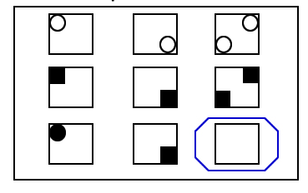

<__block>

[A] 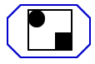

<__block>

[B] 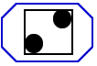

<__block>

[C] 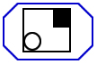

<__block>

[D] 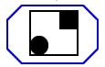

<__block>

[D]

<__question>

Type=1

<__block>

Select the item below that would complete the pattern ?

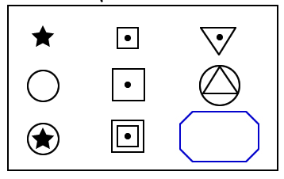

<__block>

[A] 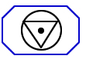

<__block>

[B] 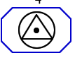

<__block>

[C] 

<__block>

[D] 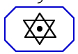

<__block>

[C]

<__question>

Type=1

<__block>

When a student asked a teacher how much time was left in an exam, the teacher replied the amount of time left is $\frac{1}{5} of the time already completed. How much time is left$?

<__block>

[A] 5 minutes

<__block>

[B] 10 minutes

<__block>

[C] 15 minutes

<__block>

[D] 20 minutes

<__block>

[B]

<__question>

Type=1

<__block>

Suppose it takes 8 monkeys 8 minutes to eat 8 bananas. How many minutes would it take 3 monkeys to eat 3 bananas?

<__block>

[A] 3 minutes

<__block>

[B] 6 minutes

<__block>

[C] 8 minutes

<__block>

[D] 2 minutes

<__block>

[C]